For Marketing/ Management Team

Analysis of Overall Sales

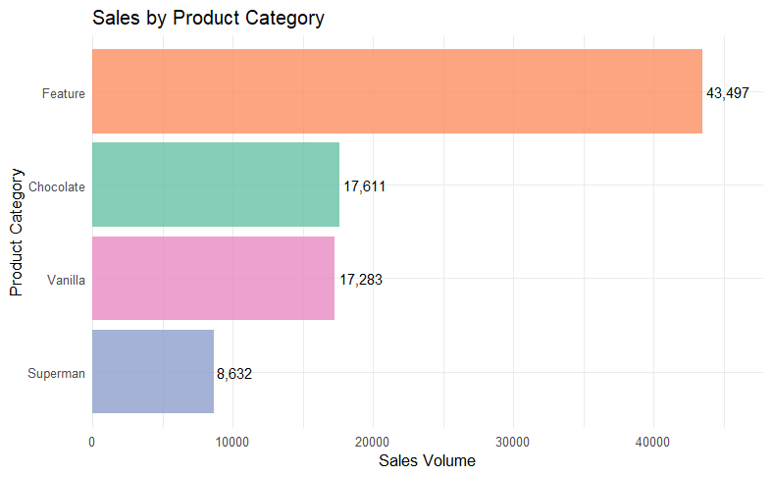

Total Sales: 87,023 units
Feature Flavors: 43,497 units (50% of total sales)
Chocolate: 17,611 units
Vanilla: 17,283 units
Superman: 8,632 units
We observed that the feature flavors drive half of our revenue. Therefore this is where we should focus our marketing on. All ice cream companies produce basic flavors but these feature flavors are unique and only we produce them. So, we have to leverage this absence of competitors and use it as the driving force of our marketing campaigns.

Focus on the Feature Flavors

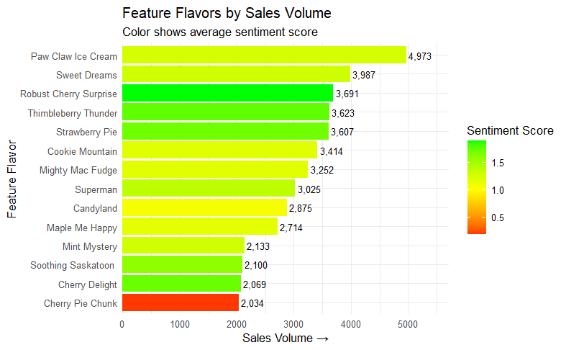
The Customer Favorites:
Leading our flavor portfolio with exceptional customer satisfaction is Robust Cherry Surprise, which has achieved the perfect balance of commercial success and customer love. With 3,691 units sold and an outstanding sentiment score of 1.89, the highest among all top-selling flavors. Customers don’t just buy it, they genuinely adore it. Close behind are Thimbleberry Thunder and Strawberry Pie, both maintaining excellent sentiment scores of 1.75 and 1.70 respectively while moving impressive volumes of 3,623 and 3,607 units. These three flavors represent our top tier where customer enthusiasm matches strong sales performance.
The Sales Powerhouses(High Sales Volume, Decent Sentiment Value):
When it comes to pure sales dominance, Paw Claw Ice Cream stands unchallenged as our volume leader. With 4,973 units sold, it is our highest-selling feature flavor by a significant margin. This flavor demonstrates remarkable market appeal. While its sentiment score of 1.24 is solid, there’s potential to elevate the customer experience to match its commercial success. Similarly, Sweet Dreams shows strong market performance with 3,987 units sold, though it appears to rely on a smaller but more intensely loyal customer base.

The Worst Performer:
Our business is a success story but it only has one outlier, one product with bad sentiment value which is the Cherry Pie Chunk. This flavor presents concern that demands immediate attention. While it has sales of 2034 units, its sentiment score of 0.18 represents the largest satisfaction gap in our portfolio. Customers are purchasing this flavor maybe because they want to try out all the flavors and trust our brand but clearly they are not enjoying the experience. Since we have a reputation of having no bad flavors according to the sentiment analysis, we must discontinue this product. It is the only product with negative sentiment value hence getting rid of it makes the most sense.

Recommendations:
So according to my analysis we should move forward with these actions immediately:
- Discontinue production of the Cherry pie chunk. Since it’s the only product with negative sentiment value, the best course of action would be to get rid of it.
- Expand production and marketing of Robust Cherry Surprise, capitalize on the cherry flavor that customers like. So, get rid of the bad cherry flavor and double down on the good one.
- Create combo packs with the top flavors. Based on my sentiment analysis we can create combo packs of the 3 top flavors that the customers love.
- Use the positive customer feedback and comments for marketing in social media platforms. Use the quotes by the customers or feature them in marketing campaigns.

Findings For the Data Team

Top 15 Meaningful Words
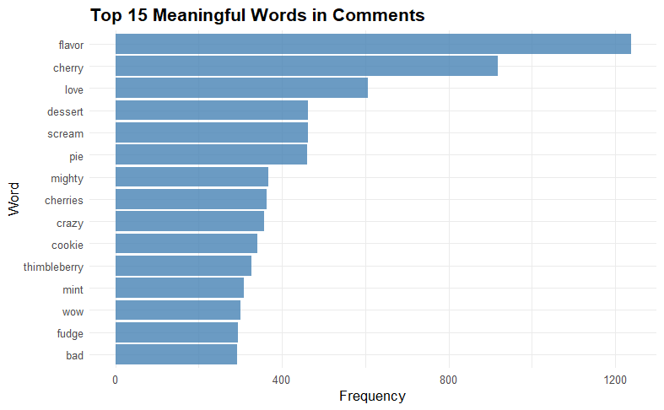
Why these words are meaningful:
Positive Emotions: “love”, “wow”, “perfect”, “delight” - These directly indicate customer satisfaction and emotional connection with products.
Specific Flavors: “cherry”, “cookie”, “thimbleberry”, “mint”, “fudge” - These reveal which specific flavors customers are mentioning, helping identify popular options.
Experience Descriptors: “flavor”, “dessert”, “pie” - These show that customers were specifying their descriptions in the comments.
Intensity Words: “mighty”, “crazy”, “scream” - These indicate strong reactions, either positive or negative, that warrant further investigation.
Words I Excluded and Why:
“ice”, “cream”, “cone” - Obvious words because I’m analyzing data of an ice cream company.
“i’m”, “there’s”, “can’t” - Common speech patterns without product insights.
“life”, “world”, “time”, “eat”, “buy” - Too generic for meaningful business decisions.
“scoop”, “mac”, “feature” - Less informative for sentiment analysis.

Word Cloud:
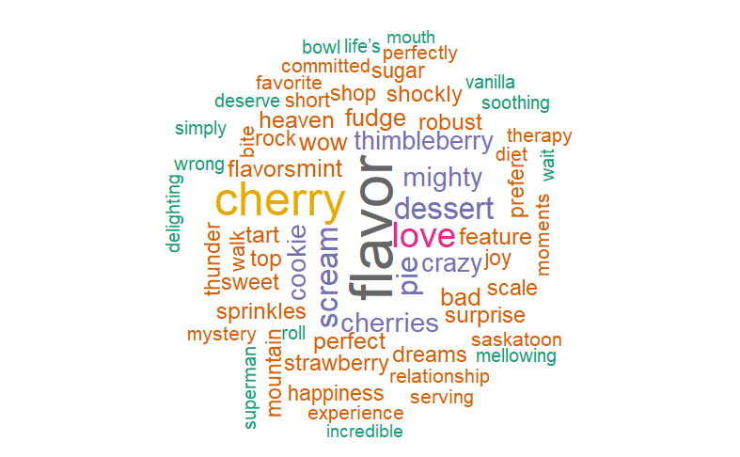

Customers with Most Comments and their Sentiment Scores:
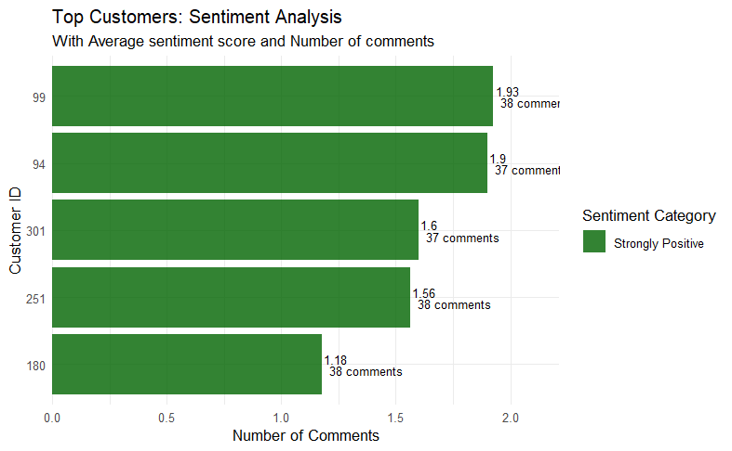

I identified the most active customers by comment count, then calculated their average AFINN sentiment scores. AFINN provides numerical sentiment values (-5 to +5) where negative values indicate negative sentiment and positive values indicate positive sentiment.
Customer ID #99: Highest average sentiment (1.93) with 52 cumulative points across 38 comments.
Customer ID #94: Near-identical high performance (1.90 average) with 38 cumulative points across 37 comments.
Strong Contributors:
Customer ID #251: Balanced positive sentiment (1.56 average) with 25 cumulative points.
Customer ID #301: Consistent positive engagement (1.60 average) with 24 cumulative points.
Moderate but Positive:
Customer ID #180: Lowest of the group but still solidly positive (1.18 average) with 20 cumulative points.
Key Business Insights
1. The narrow range of comment counts (37-38) suggests these customers are equally engaged, while sentiment variations indicate different levels of enthusiasm.
- Customers #99 and #94 are particularly valuable with sentiment scores approaching 2.0 - consider them for testimonials or referral programs.
- Consistent Quality Perception: All scores are positive, indicating no major dissatisfaction issues among your most vocal customers.

Parlor Site with Most Comments:
Across the 8 total parlor sites, we will first get a comment count and arrange them in a descending order to find the site with the highest comments. Then we will conduct a sentiment analysis on it to see if they are positive or negative.
Sentiment Assessment:
Positive (> 0): The location is meeting or exceeding customer expectations
Strongly Positive (> 0.5): Exceptional customer experiences worth replicating at other locations
Negative (< 0): Indicates operational issues needing immediate attention
Neutral (~ 0): Mixed experiences or adequate but not memorable service
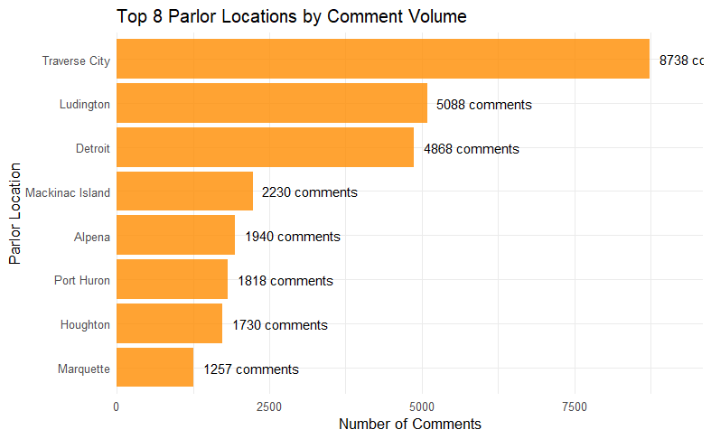

Traverse City is our most commented-on parlor location with 8,738 customer comments, and the sentiment analysis reveals strongly positive feedback with an average sentiment score of 1.53. The reason behind this is obviously the fact that Traverse city is one of the most visited tourist spots in the state. During the summer a huge traffic of tourists visit Traverse city. Customer engagement for ice cream is also high if the customers are tourists. So this explains the reason behind Traverse city being the parlor site with the highest number of comments.
Sentiment Performance:
Average Sentiment Score: 1.53 (Strongly Positive)
Total Sentiment Points: 5,258 across 3,426 sentiment-bearing words
Classification: Strongly Positive - well above the 0.5 threshold for this category
Business Implications:
Exceptional Customer Experience: The strongly positive sentiment suggests Traverse City consistently delivers outstanding service and product quality.
High Engagement: The combination of high comment volume and positive sentiment indicates customers are not just visiting, but are enthusiastic enough to share their experiences.
Operational Excellence: This location appears to be a model for customer satisfaction.

Production Site with Most Comments:
Similar to the parlor site analysis, we will first find the comment count of all the 3 production sites and arrange them in descending order to see which one has the highest comments. Then we will conduct a sentiment analysis to see if they are positive or negative.
Sentiment Assessment:
Positive (> 0): The production location consistently delivers quality products that meet customer expectations
Strongly Positive (> 0.5): Exceptional product quality that delights customers
Negative (< 0): Indicates quality control issues or product formulation problems
Neutral (~ 0): Adequate but not memorable product quality
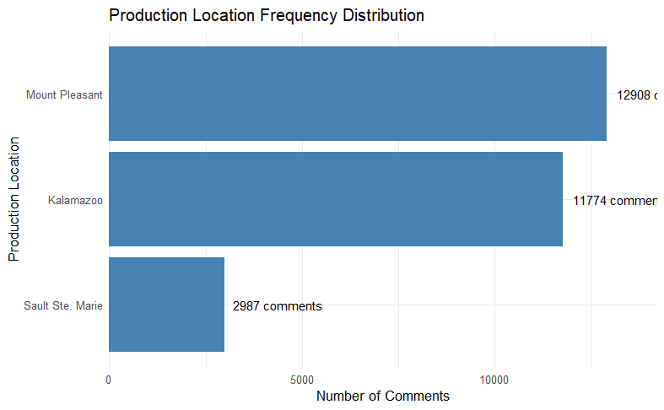
Mount Pleasant is our most commented-on production location with 12,908 customer comments, and the sentiment analysis reveals exceptionally strong positive feedback with an average sentiment score of 1.55. This high volume indicates Widespread distribution of products from this facility, a strong brand recognition and customer engagement as well as consistent product quality that prompts customer feedback.
Sentiment Performance:
Average Sentiment Score: 1.55 (Strongly Positive)
Total Sentiment Points: 7,761 across 5,017 sentiment-bearing words
Classification: Strongly Positive - exceeding the 0.5 threshold significantly

Most Frequent Comments made by Customers:

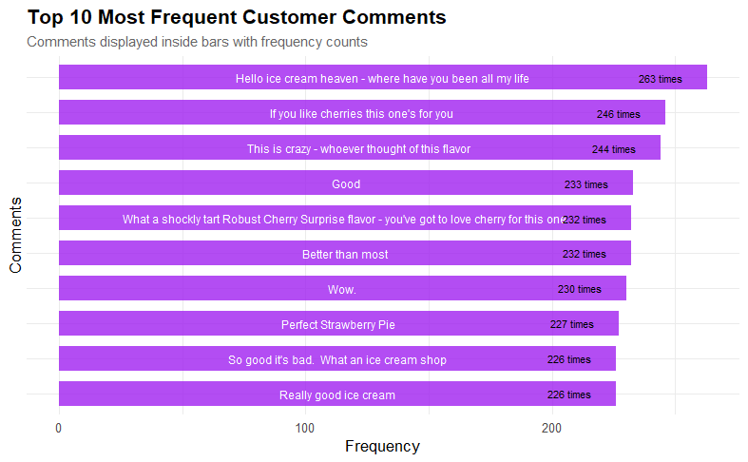

Word Network Diagram using Bigrams:

